Strategic Plan of PKSF:

Vision A Bangladesh where poverty has been eradicated; the ruling development and governance paradigm is inclusive, people-centred, equitable and sustainable; and all citizens live healthy, appropriately educated and empowered and humanly dignified life.

Mission To implement policies and action programmes involving multiple dimensions of human living and human poverty; pursue a life-cycle approach to human progress, catering to the appropriate needs at all stages of life. The policy planning and action programming centre on human beings and focus on socio-economic development and environmental protection. The support and services provided relate to education, workforce development, health and nutrition, infrastructure, inclusive and appropriate financing for planned economic activities, social issues and social capital, response to climate change impacts, gender issues, cultural dimensions, sports and social advocacy etc.

The PKSF and Its Mandate
PKSF announced its presence in the development sector of the country in 1990 with some humble yet promising accents. It may be noted that the PKSF is a public sector foundation established by the Government of Bangladesh as a not-for-profit organization. PKSF, from the beginning of its journey, has been recognized as a supplementary actor in the overall socio-economic progress of the country.Initially PKSF started different microcredit programs and projects with some local NGO’s aimed to institutionalize these organizations and to make them capable as a development entity. Through building these institutions, the ultimate goal of PKSF was to organize poor people & provide them with necessary trainings along with financial support. The mandate of the PKSF may be succinctly put as: sustainable poverty reduction and socio-economic progress through sustainable employment generation, empowerment and people’s capability development.

Initially, PKSF extended assistance to people in the form of microcredit. From 2000, PKSF stretched the financial services through different projects and programs. Training and other social development was also provided to the poor. PKSF also started some specific activities (health, job creation etc.) in a limited scale through a project named ‘PRIME’- a comprehensive program to tackle the monga situation.

Up until 2009, the PKSF, despite introduction of some diversifications in its microcredit programmes and some innovations in its approach, essentially remained a source of funding for the Partner Organizations (POs) to provide microcredit.

However, in view of the experiences of years and with the objective of addressing the multiple dimensions of poverty, PKSF started a comprehensive program named ENRICH ‘Enhancing Resources and Increasing Capacities of Poor Households towards Elimination of their Poverty’ with an understanding of the essential human dignity that the poor deserve.

ENRICH
In 2010, PKSF launched a pilot program called ENRICH. It is a programme conducted at the grassroots level focusing for overall household development of the poor by assigning one union to one PO. Poverty reduction under the ENRICH is not only with reference to the cost of basic needs-based poverty line. It takes into account multiple dimensions of poverty. The basic components are health, education, credit, environment & empowerment. One or more sub components are there under these basic indicators; and ENRICH addresses them in an integrated fashion.
At present ENRICH is being implemented in 143 unions through 6786 staffs from 110 partner organizations. The philosophy of ENRICH is people centric and it is near to total development. The underlying dynamics is that the PKSF, the PO, the union parishad and other concerned service providers work with the people joining the program to empower them to take charge of their own destiny.
This integrated action programme includes the key components of education, health services, awareness raising, skill training, information, food security andnutrition, facilitating access to asset, social capital formation, infrastructure, climate change adaptation, market linkages and so on, along with appropriate levels of funding for the ENRICH participants to implement their planned socio-economic and environmental protection related activities. Political process is also included in this approach.
That’s why this program tries to cover some basic components like healthcare, education, Credit facility, Environment and Empowerment. Under these basic components, there exist one or more subcomponents. The poor arebeing particularly facilitated to actively take part in the development process. They can feel that they are the participants in it and hence their human dignity is enhanced.

Vision
The vision of ENRICH is to create an enabling environment for the poor to achieve a humanly dignified living standard and to enjoy universal human rights.

Mission
Ensure human dignity and freedom by gradually reducing poverty in a sustainable manner, towards total elimination of poverty and beyond poverty sustainable development at the household level in the unions under the program.

Objective
The specific objectives of the ENRICH are to:
1. Attain total development of each household as well as the whole community participating in ENRICH;
2. Ensure freedom from all ‘un-freedoms’ and human dignity for all members of all households under ENRICH;
3. Empower the poor households so that they can pursue a pathway that would lead them towards the goal of human freedom and dignity;
4. Ensure access of all participants in ENRICH to all capacity enhancing activities such as education, skill training, and health services; essential institutional facilities; appropriate financing for their chosen economic undertakings; necessary market and other information; appropriate technologies; and so on.

Key Strategies of the ENRICH program
- ENRICH activities and interventions are concerned with and designed to focuson family level action, based on properly identified needs and opportunities. That’s why a Family development concept has been used for every familyliving in the ENRICH unions.
- Health is a basic need for human being. In ENRICH a universal primary healthcare system has been developed to specially address this basic need.This program has a cost recovery feature.
- Education is another basic need for human being. Considering a long term goal of building up an educated nation, ENRICH intervenes at the primary and pre primary level education. This program is very low cost and there is an opportunity to recover cost in the long run.
- Considering the economic opportunities of a family, various financial assistance program has been designed under ENRICH. All these financial assistance programs are self-sustaining.
- Taking into consideration about Environment & climate change issues, some major interventions such as Improved cooking stove (bandhuchula), Renewable energy source: solar lantern / solar home system (SHS), Biogas plants,Cultivation of medicinal plants (basakleaf), Vermi compost etc. have been taken.
- Development is a political process. Therefore a linkage with local government was also incorporated in the program through ENRICH ward center and ward committee. In order to make the program more collaborative and accelerate the community development process, these centers survey the on-going ENRICH interventions and make necessary assessment to take some measures for more pro-active involvement of the people.
- Bangladesh is now on the peak of its demographic dividend. To harvest this opportunity, ENRICH undertook youth development program. ENRICH maintains liaison with different employers and organizes job fairs to assist the young unemployed to find jobs. To deal with the problem of unemployment, Efforts are made to create both self-employment and wage or salary-based employment opportunities.
- An Initiative has been taken to build ENRICH-Home in all the ENRICH Unions by the optimum use of its available resource. ensuring health services, educational assistance, better earning, environment and living standard. Different steps have been taken to increase the productivity of those households. Besides, special steps have also been taken for rearing domestic animal like cow, goat, chicken, duck and pigeon. As a result, members of the ENRICH-Home will get healthy life and increased earnings. The core aim of this component is to restore human dignity of the poor households by eliminating their poverty. PKSF can extend this component to all over its working areas.

Key Strategies for people’s centered holistic approach
To formulate the PKSF’s strategic planning about people’s centered holistic approach, the following activities can be considered
- PKSF can start primary healthcare activities through its partner organizations (like ENRICH) all over Bangladesh. As health is a basic need, this Universal these 2 components of the ENRICH program in all of its working areas. By the implementation of the Health program which will reduce the health related cost and will increase the productivity of the people. This program also has the cost recovery feature.
- The education program is very low cost and there is a good possibility to recover cost in the long run, so this component can be spread to the working areas of PKSF. As research suggests, the motivation to go to the school has increased for children and children from the more disadvantaged backgrounds have been served better by these schools.
- To deal with the problem of unemployment, Efforts are made to create both self-employment and wage or salary-basedemployment opportunities. Job linkage initiative following the framework of the ENRICH youth development program maintains liaison with different employers and organizes job fairs to assist the young unemployed to find jobs. To use the benefit of demographic dividend, this component can be strengthened. Demand for such training program is increasing, which should continue in this vital point of time.PKSF has a broader approach to youth employment or skill development for the rural youth targeting this as the key agents for socio-economic development and technological innovation of the country.
- Gradually PKSF may consider spreading other components like ENRICH center, solar, improved cooking stoves, vermi compost, water & sanitation, beggar rehabilitation, medicinal plant cultivation activities & ENRICH special financial service for achieving human dignity.

INCLUSIVE FINANCIAL SERVICES: STRATEGIC PLANNING OF PKSF
Promoting inclusive financing is one of the core objectives of PKSF. Considering the heterogeneity of different poverty groups living in different regions of the country, PKSF strives to address their diverse financial needs. These groups include moderate poor, ultra-poor, micro-entrepreneur and marginal & small farmers. Vulnerable areas, such as coastal, haor, char, hill-tracts, draught and flood-prone, and economically backward areas are given priority during the selection of geographical locations for programme interventions.
Over the time, PKSF has diversified its financial services with many folds. With its financial interventions, PKSF has created employment opportunities for more than 8.5 million families of the country. Since 2009, PKSF has been emphasizing on people-centric development approach which encompass inclusive financing . In this context, PKSF intends to revisit its financial interventions to serve more efficiently to the program participants, particularly the underprivileged section of population.
Financing the moderate poor: The contribution of agricultural sector to GDP has been reducing gradually over the last three decades. Similarly, the scope of employment opportunities has also decreased during this period. In this backdrop, PKSF, in the early nineties, started its activities by launching credit programmes for the rural moderate poor to create employment opportunities in the rural off-farm sector. The objective was two-folds: one was to create new employment opportunities, and the other was to reduce the pressure on the crop sector for employment. Later on, finding enormous demand and opportunities in the urban areas, PKSF also extended its services to the urban moderate poor.

Vision: The vision of the program is to ensure servicing all deserving moderate poor, particularly non-agro based, with finance and relevant interventions they need to bring them out of poverty.

Strategy: The strategy to attain the vision would include:

- Provide needed financial services to all of the target groups.
- Ensure accurate selection of participant households.
- Educate the participants to run the IGAs more efficiently.
- Ensure gradual increase of the family investment in economic activities, than consumption.
- Ensure risk mitigating mechanism for the participant.
- Improvement of all life indicators of members of the participant households.

Financing the ultra-poor: The ultra-poor have always been left out from traditional financial services due to self-exclusion, social exclusion and institutional exclusion. The fundamental reasons behind these include: weak socio-economic conditions, lack of confidence and perceived weak entrepreneurial abilities of the ultra-poor. The classical microcredit required to include some encouraging elements in its practice to ensure inclusion of ultra- poor. Considering all these constraints, PKSF devised a flexible financial service to include the excluded. Distinct features of this service are lower interest rate with flexible repayment system. PKSF continuously induces its POs to undertake necessary steps to eliminate the barriers of social and institutional exclusions. At present, PKSF is running the country’s biggest financial programme for the ultra-poor. Along with providing flexible financial services, PKSF initiated a specially designed project entitled ‘Programmed Initiatives for Monga Eradication (PRIME)’ in 2006 to prevent the negative impacts of Monga in the North, and situations similar in the South. Since 2013 PKSF has been implementing another special project named ‘Uzzibito’ to provide the skill development training and primary health care & nutritional support for the targeted people to effectively change their livelihood.

Vision: The vision of the program is to ensure reaching the lowest income group willing to be included in the program with financial and relevant services towards freeing them out of extreme poverty by 2030.

Strategy: The strategy to attain the vision would include:

- Ensure providence of needed services, both financial and non-financial, to the extreme poor so that they can attain at least a moderate level of income.
- As it is subsidized program, effective selection of participants would be needed so that the deserving candidates are covered.
- Providing different kinds of Skill Development Training to the youth of ultra poor
families to create both wage and self-employment opportunities for them.
- Reduce the number of extreme poor dependent on physical labor and promote technology based higher productive employment for them.
- Ensuring risk-mitigating mechanism for the participant.

Financing the micro-entrepreneur: Micro-enterprises are considered engines of economic growth that create both gainful self-employment for micro-entrepreneurs and wage employment opportunities for the ultra-poor. Recognising the potential of this sector, PKSF launched its microenterprise programme in 2001 to meet the larger demand for credit of the micro-entrepreneurs. Under this programme, an entrepreneur can access a credit facility up to BDT 1 million and enjoys flexibility in repayment and amortisation period. They are also eligible to get working capital loan amounting up to BDT fifty thousand.

Vision: By adopting business-cluster development approach through appropriate interventions in the value chain, helping micro entrepreneurs in having their brands and thereby helping them in up scaling their economic activities into a productive and fulltime employment generating activities
.
Strategy: The strategy to attain the vision would include:

- Reaching 2 million micro entrepreneurs by 2020 with enhanced financial services.
- Scaling up of the lower ceiling of loans to USD 25000 by 2020.
- Making value chain interventions to business clusters comprising micro enterprises
- The working capital loan would be increased to meet the seasonal demand of the micro enterprises.
- New financial products like start-up capital, lease financing etc. would be introduced for the micro entrepreneurs.
- Promoting technology based services to the enterprises; like introduction of e-commerce, e-marketing etc..
- Attainment of at least three full-time employment in one enterprise by 2020.
- Ensure a significant part of the wage-employment from ultra poor families in Micro enterprises.
- Ensure all the micro entrepreneurs will comply with the regulation of Environment Friendly Entrepreneurship.
Financing the marginal and small farmer: The marginal and small farmers are considered as core driving forces of the economy. The lack of access to finance has always been one of the major constraints of the farming communities, in particular marginal and small farmers. Higher degree of covariant risk, inadequate agricultural credit services of formal institutions, and the rigid microfinance operational modality hindered the inclusion of farmers into the mainstream financial system. Considering the diverse financial needs of farmers, PKSF has been implementing a specially designed agricultural lending programme since 2005. The salient features of this service include provision of flexible repayment mode, such as one shot, seasonal, balloon or modified ballon repayment, consistent with the seasonal agricultural activities; and the flexibility of having multiple loans to diversify their production. To provide technological supports to the farmers, recently PKSF has set up two units, namely, Agriculture unit and Livestock unit.
Vision: Rendering the marginal and small farmers with services, particularly financial and technological ones, for bringing them out of poverty and making them effective contributors to the attainment of national food security.

Strategy: The strategy to attain the vision would include:

- Reaching the marginal and small farmers with timely and need based financial services with appropriate and sustainable technological support.
- Reaching at least half of the marginal and small farmers yet to receive financial services from any institution.
- Rendering target oriented value chain interventions, including agri-business and market linkage.
- Ensuring a risk coping mechanism, including crop, life and health insurance.
- Involving the marginal and small farmers in location based agricultural production, processing, marketing and exporting.
- Supporting marginal and small farmers to adapt and mitigate climate change effects like flood, drought and salinity.
- Connecting the marginal and small farmers with Information and Communication Technology.
- Alternating livelihoods/rehabilitation programme for marginal and small farmers.
Strategic Planning of PKSF :Social Protection
The sustainable poverty reduction does not only depend on creating income opportunities, but also depend on protecting income erosion due to various perturbations. The poor suffer from losses of income from time to time due to natural hazards, personal difficulties, insufficient capacities, adverse market behaviour, and various other reasons. It is also to be noted that Bangladesh is one of the most vulnerable countries to climate change. Major climate change effects, such as changing and shifting pattern of rainfall and temperature, floods, cyclones, storm surges, salinity ingress, and drought are major sources of vulnerability. The vulnerability of the affected people, mostly the poor, is exacerbated each time they suffer a devastating climatic-related event, and such events are increasing as a consequence of climate change. The cumulative effect of these disasters creates a vicious cycle, pushing the affected non-poor to the ranks of the poor, the poor to the ranks of the extreme poor, and the extreme poor to the ranks of destitute. Keeping the foregoing in mind and helping to achieve the targets of sustainable poverty reduction in Bangladesh, PKSF has adopted inclusive, equitable and sustainable social protection strategies that have, broadly, the following four key dimensions.

1.0 Protective social protection
The objective of protective social protection is to address vulnerabilities to food insecurity focusing on programmes that offer a protection to vulnerable groups from economic and social deprivation and that reduce poverty and vulnerability. To achieve the stated objectives, PKSF will take the following strategies. These include:

Strategies:
  - Designing health, life, livestock and credit-life insurance services
  - Forming a covariant risk fund
  - Partnering with Mutual Benefit Associations
  - Collecting time-series morbidity data for actuarial calculations
  - Working on demand creation for insurance services
  - Creating a pool of ‘Disaster Management Fund (DMF)’ for the restoration of livelihoods, such as repairing houses, tube wells and latrines; providing urgent medical services; re-establishing IGAs and procuring consumer items to meet emergency needs and to tackle adverse situations
  - Undertaking cash-for work activities to create temporary employment for the unemployed and also to rebuild community infrastructures and homestead of the poorest just after any disasters

- Preventive social protection
The objective of preventive social protection is to protect people from risks and shocks focusing on preventing risks and shocks by improving adaptive capacity. To achieve the stated objectives, PKSF will take the following strategies. These include:

Strategies:
  - Providing community-based adaptation responses mainly in flood-prone, drought-prone and saline- prone areas following the guidelines of ‘Bangladesh Climate Change Strategy and Action Plan (BCCSAP)’ adopted in 2009
  - Promoting adaptation response in agriculture sector, such as introducing stress-tolerant varieties
  - Encouraging mitigation responses, such as promoting tree plantation and facilitating energy-efficient cooking stoves
  - Facilitating adaptation responses to water sector, such as helping to install rain water harvesting unit at the household level
  - Working to combat vector-borne diseases due to climate and environmental change
  - Mainstreaming ‘Disaster Risk Reduction (DRR)’ and ‘Climate Change Adaptation (CCA)’ in all activities of PKSF
  - Creating employment opportunities and diversification of income sources
- Promotive social protection
The objective of promotive social protection is to increase human and physical capital at the household level by facilitating access to essential social services, such as education, skills, health, housing and water. To achieve the stated objectives, PKSF will take the following strategy. These include:
Strategies:
  - Transferring productive assets as a form of grants to the poor, particularly to the destitute
  - Establishing dedicated fund, such as Programme-Support Fund and Special Fund for supporting education, health and other social development programmes
4.0 Transformative social protection
The objective of transformative social protection is to address the underlying causes and causal relationships of social vulnerability for reducing social exclusion focusing on equity and social cohesion along with socio-economic development. To achieve the stated objectives, PKSF will take the following strategies. These include:
Strategies:
  - Designing PKSF’s programmes and projects considering the excluded from all walks of life
  - Designating a unit to promote pro-poor policies, minority rights and anti-discrimination campaigns, such as ‘Social Advocacy’ unit at PKSF

Capacity Building
Capacity building of PKSF involves the process by which people, partner organizations and society systematically stimulate and develop their capability over time to achieve social and economic goals, through improvement of knowledge, skills, systems, and institutions - within a wider social and cultural enabling environment (Figure 1).
PKSF capacity building takes place at three different levels: the individual member level, the partner organizational (PO) level and the PKSF level. These three levels are interlinked and interdependent. As strengthening members’ capacities, POs’ capacity and PKSF’s own is a dynamic issue, PKSF addresses this process of change, and hence manages transformations at all three levels on continuous basis. To this end PKSF focuses on identifying appropriate development policies and strategies that work best to strengthen abilities, networks, skills and knowledge base of these two levels.
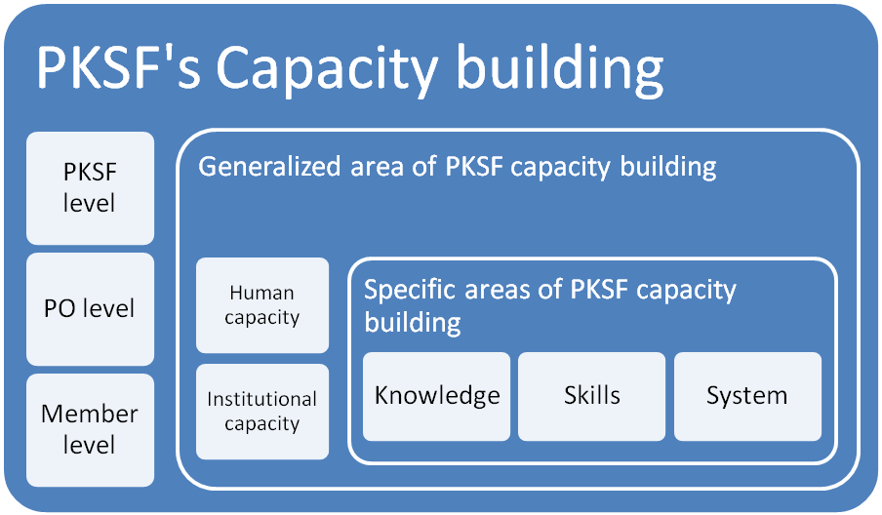

Figure 1. Concept of PKSF’s capacity building along with its goals and areas
- Human capacity building
Human capacity building at PKSF, PO and member level aims to address the changing needs of the overall development goal of Bangladesh, which is itself in a transitional phase from developing country to middle income country. Possible areas of human capacity building of PKSF, PO and member is shown in Figure 2.
- Inclusive financing : PKSF is already offering inclusive financial services for extreme poor, moderate poor and non-poor borrower. PKSF staffs need to be trained on different kinds of financial products catering the specific needs of different types of borrower.
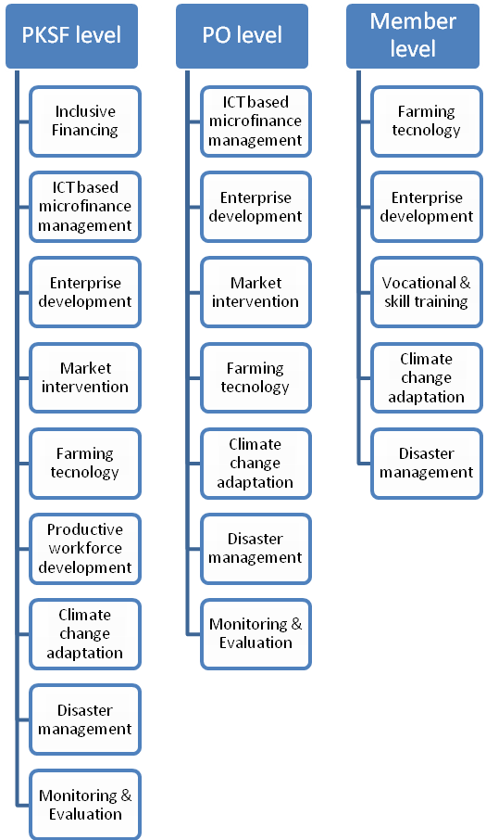

- ICT-based microfinance management : In coming days expected major transition of both PKSF and its POs is from their mostly manual based operational management and financial management to fully ICT based operational and financial management. This needs major capacity building of both PKSF & PO staffs.

- Enterprise development: Staff of PKSF & POs and members will be trained to address operational and financial management of different types of cluster-based farming enterprises and off-farm enterprises. This may include value chain intervention needed for improved productivity, quality assurance and certification.

- Market Intervention: Both PKSF & POs staffs and members will be trained to address specific market intervention. This may include but not necessarily limited to products grading, assurance of national/international compliances and branding of products.
Figure 2. Possible issues of human capacity building at PKSF & PO levels and at member level

- Farming technology: PKSF & PO staffs and member will be trained on appropriate technologies related to production, post-harvest processing, preservation, value-addition and marketing of farming products.

- Productive work-force development: PKSF staffs will be trained to develop market demand based productive workforce development through vocational & skill development training. This may include but not necessarily limited to selecting right trade, selecting training providers, selecting right member for training, and more importantly job-placement or creating self-employment.

- Climate change adaptation: All stake holders, i.e., PKSF & PO staffs and members will be trained for climate change related adaptation activities. This may include resilience development of all categories of members against economic, social, health or environmental disaster.

- Disaster management: All stake holders, i.e., PKSF & PO staffs and members will be trained on disaster cooping for all categories of households especially for extreme poor and moderate poor (Short Term). This may include pre-impact preparation (e.g., awareness & infrastructure building), emergency response to disaster impact and post-disaster mitigation activities. Stake holders will also be trained on long-term disaster resiliency development especially for extreme poor and moderate poor through their capacity development and livelihood enhancement (Long-Term).
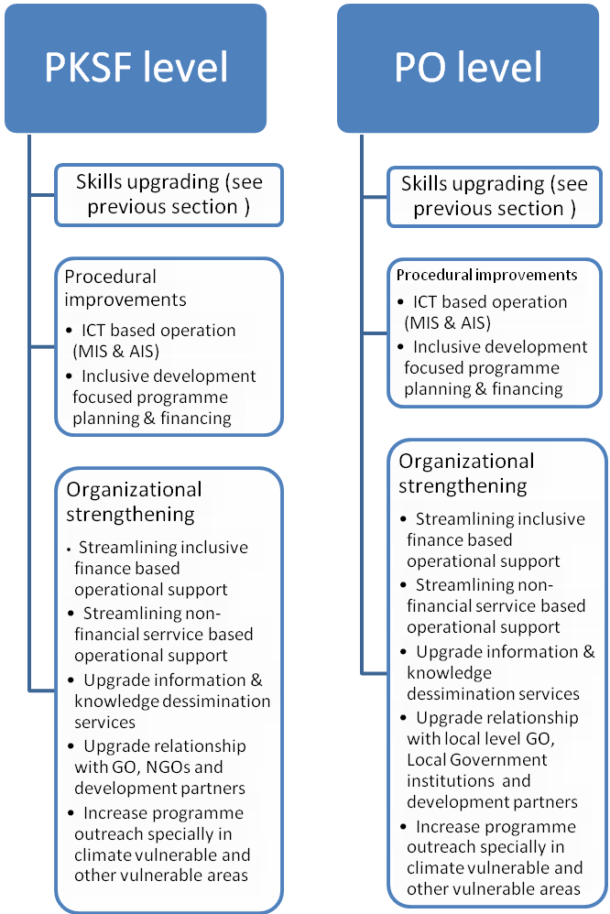

- Monitoring & Evaluation: PKSF & PO staffs and member will be trained on monitoring and evaluation (M & E) activities. This may include but not limited to improvement of on-site and off-site monitoring of financial and non-financial services through ICT-based monitoring system. Here use of Real-time Results Based Monitoring (Rt-RBM) at output, out-come and impact level would be important. Rt-RBM may help to further improve programme design and implementation strategy.
Figure 3. Possible issues of institutional capacity building at PKSF & PO levels

- Institutional capacity building

It building will addresses capacity building beyond the provision of education, skills and training of professionals. It aims to enhance the capacity of governance, business and planning of both PKSF and POs to plan and manage their affairs coast efficiently and effectively. This implies addressing capacity building on a long-term and strategic level through skill upgrading, procedural improvements, and organizational strengthening (see Figure 3). Skill upgrading of both PKSF and PO have been discussed earlier section.

- Procedural improvement: Procedural improvement of both PKSF and PO include their adoption of ICT based MIS and AIS through using appropriate software and hardware. To address inclusive development issues of member households both PKSF and PO will adopt procedure conducive to cater field demand.

  - Organizational strengthening: Both PKSF and PO will streamline inclusive financial service based operational support to its members. They will be capacitated to provide non-financial services like primary health care, education, technical services to targeted member. Accordingly they will upgrade information & knowledge dissemination services, relationship with GO, NGOs and development partners. Programme outreach will be increased especially in climate vulnerable and other vulnerable areas
Strategic Plan: Research and Development
- Background
Research and development is one of the means by which an organization can accelerate future growth by developing new products or processes to improve and expand its operations. It plays an important role in enhancing the capability of an organization through stimulating innovative methods of production, reducing costs and improving product quality. In general, there is a positive relationship between research and development, and organizational productivity. With this backdrop, Palli Karma-Sahayak Foundation (PKSF) as an apex development organization has created Research Division headed by Director (Research).
Research activities of PKSF aim at providing the needed inputs and impulsion for efficient design and implementation of its diverse activities. PKSF’s research division operates in a three-fold manner to conduct its research activities: in-house action research, collaboration with other institutions/individuals, and outsourcing. Apart from regular monitoring and research, PKSF has adopted a Results-based Monitoring (RBM) system to track the progress of its different interventions.
PKSF, based on its past experiences and lesson learnt, has reshaped its core goal as ‘establishing human dignity’ instead of limiting its efforts towards achieving economic freedom only and started new programs for attaining this goal. Therefore, over the time research areas of PKSF have been diversified. It includes baseline survey and impact evaluation of different projects and programmes, action and policy research on demand-lead issues like poverty, employment, microfinance, insurance, health, education, nutrition, agriculture, livestock and poultry, fishery, etc. Exploring future development intervention areas based on completed research of PKSF is also one of the important activities of research division of PKSF. Some important areas of future research of PKSF have been identified in a meeting of senior officials of PKSF held on 23 September 2015. These are effective capacity development process for poverty reduction, suitable loan products for poverty reduction, debt suitability of microfinance borrowers, effectiveness of value chain, quality and sustainable employment creation, effective process of confidence building and inclusion of ultra poor, feasibility of crop insurance, effectiveness of adoption of modern agricultural technologies, effectiveness of insurance and disaster management strategies, capacity development of research division of PKSF. Moreover, Results-based monitoring is also an integral part of research. In this context, preparation of strategic plan for research and development is very much crucial for PKSF. It will make the research division more effective and will contribute more to PKSF and the nation.
- Strategic Plan on Research and Development
Research and development activities of PKSF have been classified into four major categories. These are baseline survey and impact evaluation, action/policy research, exploration of development intervention areas based on completed research of PKSF and results-based monitoring. Strategic plan on research and development of PKSF for the next five years has been prepared as follows:
Research Categories | Research Areas | Major Objectives | Responsibility | Source of Fund
- Baseline Survey and Impact Evaluation | - Baseline survey on different projects and core programmes of PKSF  - Terminal (e.g. initial, mid-term, end of project and long-term) evaluation of different projects and programmes | - Assess the starting situation on objectively verifiable indicators of different projects and programmes  - Assess the initial, mid-term, end of project and long term achievement of results against objectively verifiable indicators of project and programmes.  - Assess causes of success or failure of project and programmes  - Document lessons learned from the projects or programmes | - Outsourcing with the technical support and guidance of research division | - Respective project and programme
- Action/Policy Research | - A Comparative Assessment on Effectiveness of Different Capacity Development Process for Poverty Reduction | - Identify the effective capacity development process for poverty reduction of ultra poor | - Research Division of PKSF | - Main stream
 | - Suitable loan Products for Poverty Reduction | - Identify the different types of loan products available for poverty reduction  - Assess and find out the suitable loan products for poverty reduction | - Research Division of PKSF | - Main stream
 | - Debt Suitability of Microfinance Borrowers | - Identify different sources of debt of microfinance borrowers  - Determine the problems and prospects of different sources of debt  - Determine the causes of formal and informal sources of debt  - Identify the suitable sources of debt for microfinance borrowers | - Research Division of PKSF | - Main stream
 | - Effectiveness of Value Chain | - Identify the value-creating processes of the products ;  - Assess which value each particular activity adds for each segment of the products or services;  - Identify the key success factors for each segment of the value chain. | - Research Division of PKSF | - Main stream
 | - Quality and Sustainable Employment Creation through Microfinance | - Assess the types and number of employment created through microfinance;  - Assess the wage rate according to different types of employment and gender  - Identify the factors contributing to employment creation;  - Assess the available and required skills for the sustainable employment | - Research Division of PKSF | - Main stream
 | - Effective Process of Confidence Building and Inclusion of Ultra Poor in Poverty Alleviation Programmes | - Identify the different types of confidence building process of ultra poor and find out the effective one.  - Assess the factors related to inclusion of ultra poor in poverty alleviation programmes. | - Research Division of PKSF | - Main stream
 | - Feasibility Study on Introduction of Crop Insurance | - Assess the opinions of the farmers regarding the crop insurance  - Assess the financial viability of crop insurance  - Determine the premium size for different insurance schemes | - Research Division of PKSF | - Main stream
 | - Effectiveness of Adoption of Modern Agricultural Technologies | - Assess the farmers knowledge and practice on modern agricultural technologies  - Determine the factors related to adoption of modern technologies  - Determine the marginal productivity of different technologies  - Assess the benefit cost-ratios of different crops under different technologies  - Assess the farmers’ affordability of different technologies | - Research Division of PKSF | - Main stream
 | - Staff Drop Out from MFIs: Patterns and Causes | - Determine the trend in drop out of different types of staff of MFIs;  - Identify the pattern and causal factors of staff drop out;  - Assess the consequences of staff drop out and  - Formulate suitable strategies for reducing staff drop out. | - Research Division of PKSF | - Main stream
 | - Debt Servicing Capacity of Microcredit | - Determine the proportion of enhanced income of microcredit clients required to service debt. | - Research Division of PKSF | - Main stream
 | - Leadership Succession in MFIs: Patterns and Trends | - Assess the existing management succession pattern in MFIs;  - Investigate the relationship between good performance and corporate management succession practice and  - Recommend strategies to develop corporate management succession practice. | - Research Division of PKSF | - Main stream
 | - Return on Investment and Debt-Equity Mix of IGAs of Microcredit | - Determine the weighted cost of fund for investment of the microcredit participants having varied debt-equity mix;  - Assess the return on investments of different IGAs having different debt-equity mix; and  - Determine the spread between the rate of interest of microcredit and return on investment of different IGAs. | - Outsourcing or jointly with Research Division | - Main Stream
 | - Effectiveness of Insurance and Disaster Management Strategies | - Assess the knowledge and practice on insurance policy and disaster management strategies  - Determine the households received benefit of insurance and cope with the disaster;  - Determine the households adopted disaster management strategies and cope with the disaster  - Find out the existing problems and probable solutions for effective implementation of insurance and disaster management strategies | - Outsourcing in collaboration with Research Division | - Main stream
 | - Sustainability of PKSF: Seeing Own for Furtherance of Institutionalization | - Assess the institutional sustainability  - Assess the financial sustainability  - Assess the human resource quality  - Investigate the optimum balance between or among financial, social and other relevant aspects | - Outsourcing | - Own fund (or can search for fund from the development partners)
 | - MFIs in the Crossroads: Compulsion of Taking Funds from Commercial Sources for Microcredit Programme | - Assess the increased needs of funds of the MFIs  - Estimate PKSF segment in MFIs’ on-lending funds for Microcredit  - Assess whether commercialization is affecting declared norms of microcredit  - Explore the balance between their sustainability and poverty alleviation objectives | - In collaboration with quality think tanks e.g. BIDS or InM | - Own fund (or can search for fund from the development partners)
 | - Tackling Challenges by the MFIs in the Field Operation of Programmes | - Figure out the challenges  - Investigate the reasons for emerging the challenges  - Suggest way forward to face the challenges | Research Division in collaboration with Operations Department | - Own fund
- Exploration of Development Intervention Areas Based on Completed Research of PKSF | - Important Findings, Policy Recommendations and Development Intervention Areas of Research Completed during the Last Five Years under PKSF | - Extract the important findings and recommendations from the previous studies of PKSF  - Identify development intervention areas against extracted findings and recommendations | - Research Division | - Extra fund will not be required
- Results-based Monitoring | - Continuous Assessment of Immediate, Intermediate and Long Term Results of Different Projects and Programmes | - Assess the progress against the immediate, intermediate and long term results-based indicators.  - Identify the gap between the target and achievement along with the causes  - Formulate strategies for mitigating the identified gap and provide feedback to the management authority for corrective measures | - RBM unit and respective project in consultation with Research Division.  - RBM unit may be merged with Research Division. | - Respective project and main stream

- Capacity Development of Research Division
Research division of PKSF is not yet well equipped. It has inadequate resources for conducting required number of researches. Currently, there are only four research staff including Director (Research). It should be increased to ten by the next five years. In addition, there should be field management and data processing staff with computer. Capacity of research staff should be enhanced and updated especially in the areas of research methodology including advanced econometrical and statistical techniques for data analysis and report writing. Long duration training course for younger staff and short duration training course for senior staff may be organized at home and abroad. Once the Research Division is equipped, Results-based Monitoring (RBM) unit should be merged with Research Division, because results-based monitoring is very much related to research.

- Monitoring the Strategic Plan
On the basis of the above five years strategic plan, research division will prepare and implement annual research plan. Implementation progress of research plan will be monitored by the Managing Director of PKSF. Moreover, progress report on research will be presented at the monthly coordination meeting and will be reviewed by the members present in the meeting including Managing Director.

. 2.. EMPOWERMENT IS KEY TO POVERTY ERADICATION AND HUMAN DIGNITY A New Holistic PKSF Approach : ENRICH Qazi Kholiquzzaman Ahmad
A Holistic Approach to Household-focused Poverty Eradication A new Initiative of PKSF

